Le problème que nous présentons ici concerne la distribution du béton qui est le matériau de construction le plus utilisé au monde. La construction représentait en 2014 6.6 % du PIB du Canada avec des millions d’emploi.

La production et distribution de Ciment et béton

Ciment-Béton

14

Le nombre d’usines exploitées par les membres de l’ACC.

13 millions

Le nombre de tonnes de ciment produit par les membres de l’ACC en 2014.

1,6 milliard $

L’équivalent en dollars de la production Canadienne de ciment en 2014.

460 millions $

L’équivalant en dollars des exportations de ciment, principalement aux États-Unis, en 2015.

Ce projet est étudié en collaboration avec la division Unibéton de Ciment Québec Inc. (CQI) qui produit et exploite le ciment et béton au Canada et aux Etats-Unis, plus particulièrement dans les provinces du Québec, des Maritimes et de l’Ontario ainsi que dans les États du Vermont, du New Hampshire, du Massachussetts, du Maine et du Rhode Island.

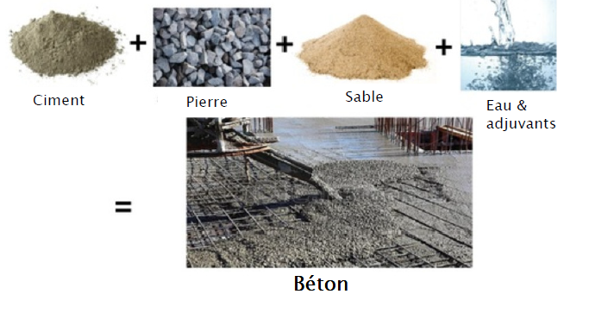

Unibéton vend du béton en quantité suivante prêt à l’emploi en sacs de 30 kg ou de 40 Kg. Pour une quantité plus importante de béton, les commandes sont livrées par des bétonnières ou camion malaxeur à béton.

Plusieurs tailles différentes de bétonnières sont utilisées

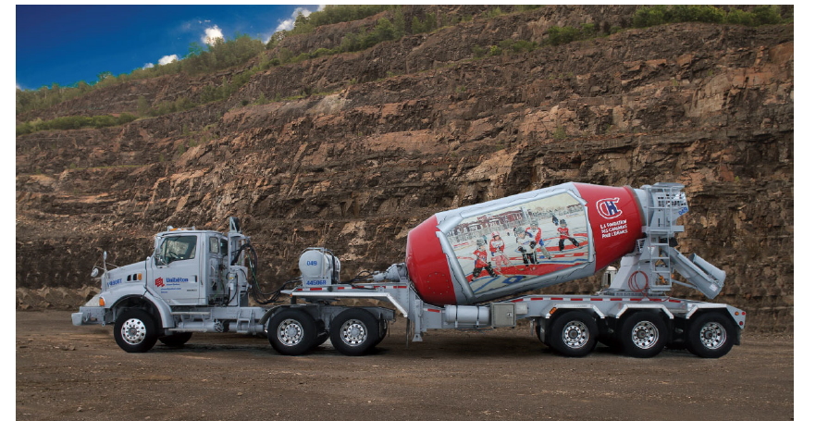

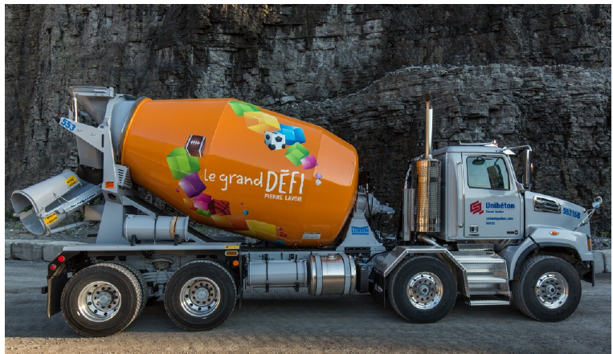

Unibéton produit plusieurs types de béton pour des besoins spécifiques.

|  |  |
| --- | --- |
| Nom | Utilisation |
| **UNISOLANT™** | **Béton pour coffrage isolant** |
| **UNIGEL** | **Béton pour temps froid** |
| **UNIPLAN™** | **Béton pour dalles sur sol résidentielles** |
| **AGRIMIX** | **Béton agricole** |
| **UNIFLOW** | **Béton autoplaçant** |

Flow chart des opérations

Contraintes

* Nature du produit
* Plusieurs types de béton
* Différents temps de chargement
* Différents temps de déchargement
* Opération de refroidissement
* Déplacement sur le chantier
* Attente sur le chantier pour le déchargement
* Multiples voyages pour servir le client
* Livraison à une heure donnée (Pas avant pas après)
* Literature review

**A Classification Scheme for Vehicle Routing and Scheduling Problems**

**Desrochers et al.**

For each vehicle or driver, a route and a schedule is provided. Generally, the route specifies the sequence

of locations to be visited and the schedule identifies the times at which the activities at these

locations are to be carried out.

Crew scheduling problem

In crew scheduling, the primary concern is to sequence the movements of a crew in space

and time so as to staff the desired vehicle movements. While crew scheduling problems are

essentially similar to vehicle scheduling problems, the former generally involve more complicated restrictions, such as requirements for crew lunch breaks, union regulations

*the single depot vehicle scheduling problem

*the single depot vehicle scheduling problem with length of path restrictions

*the single depot vehicle scheduling problem with multiple vehicle types

*the multiple depot vehicle scheduling problem

*the fixed location worker scheduling problem

*the mass transit crew/vehicle scheduling problem

*the air crew scheduling problem

*the rostering and bid line problems.

* Vehicle scheduling problem with length of path restrictions (VSPLPR)

constraints are placed on the length of time a vehicle may spend away from the depot or the mileage a vehicle may cover without returning to the depot for service. This constraint commonly encountered in

practice corresponds to fuel restrictions, maintenance considerations, etc.

* *Vehicle scheduling problem with multiple vehicle types* ( *VSPMVT)*
* *Vehicle scheduling problem with multiple depots (VSPMD)*
* bid line problem

The bid line

problem[214] refers to the problem of sequencing sets of these pairings into monthly work

* plans for individual crews.

Tractor-trailer routing and scheduling with full loads

A common commercial distribution problem entails the routing and scheduling of the tractor

portion of tractor trailer trucks where the trailers are assumed to have a full load. The term full

load means that a trailer is attached to the tractor and is transported directly from a pickup

point (the origin) to a delivery point (the destination). The load on a trailer has a unique and

specified destination and is not to be split among different destination locations. The capacity of

a tractor is one trailer. Since each trailer is transported from its origin to its destination, this

problem obviously involves precedence constraints. A typical route for a tractor may be as

follows (see Fig. 4.3)

The demands are specified in terms of the number of trailer trips between origin/destination

pairs. Given this demand data, one may address the following two decision problems:

Problem 1. Minimize the total distribution cost for handling all origin-destination demands.

Problem 2. Determine the optimal fleet size required to service a subset of the origin destination

demands given that the remaining demand is to be serviced by common carrier.

Bell et al. (1983), Brown and Graves (1981), Brown et al. (1987), and Powell et al. (1988) have all attempted to implement computerized optimization models for real-time

operations.

powell2002implementing

THE LOAD-MATCHING PROBLEM

The load-matching problem of truckload trucking seems,

on the surface, to be surprisingly simple. At any one point

in time, there may be several hundred drivers that are available

to be assigned to a load (or are expected to become

available in the near future), and several hundred loads that

need a driver to pick up the load and carry it to the destination.

The challenge is finding the right driver to assign to

the right load.

{Real-time dispatch of petroleum tank trucks

brown1981real